Decision for treatment

Doctor’s phone

Database

Server (observing data)

Big data analytical tool

Sensors

Microcontroller

Smart phone

no

Abnormal data

Require any test?

yes

Cloud Server with database

Microcontroller ( Arduino Uno)

Max30105 sensor

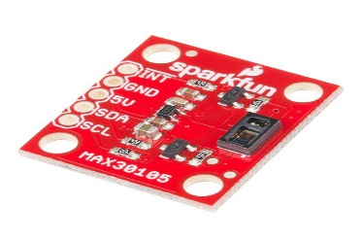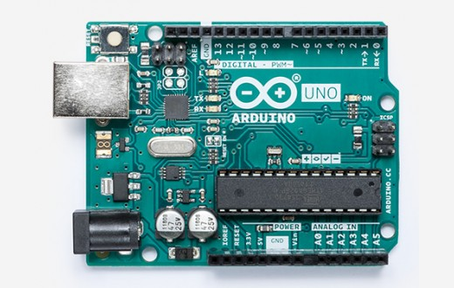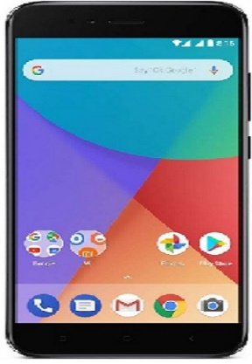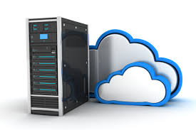

Generating Report and Make Decision

Temperature Sensor